**400 EGP**

**water pump**

**component of water pump:**

**1-Inlet: where the liquid is absorbed.**

**2-Motor + fan: responsible for generating kinetic energy that extracts water from the inlet and sends it through the outlet.**

**3-Production: It is the inlet through which the fluid driven by the force of the water pump exits.**

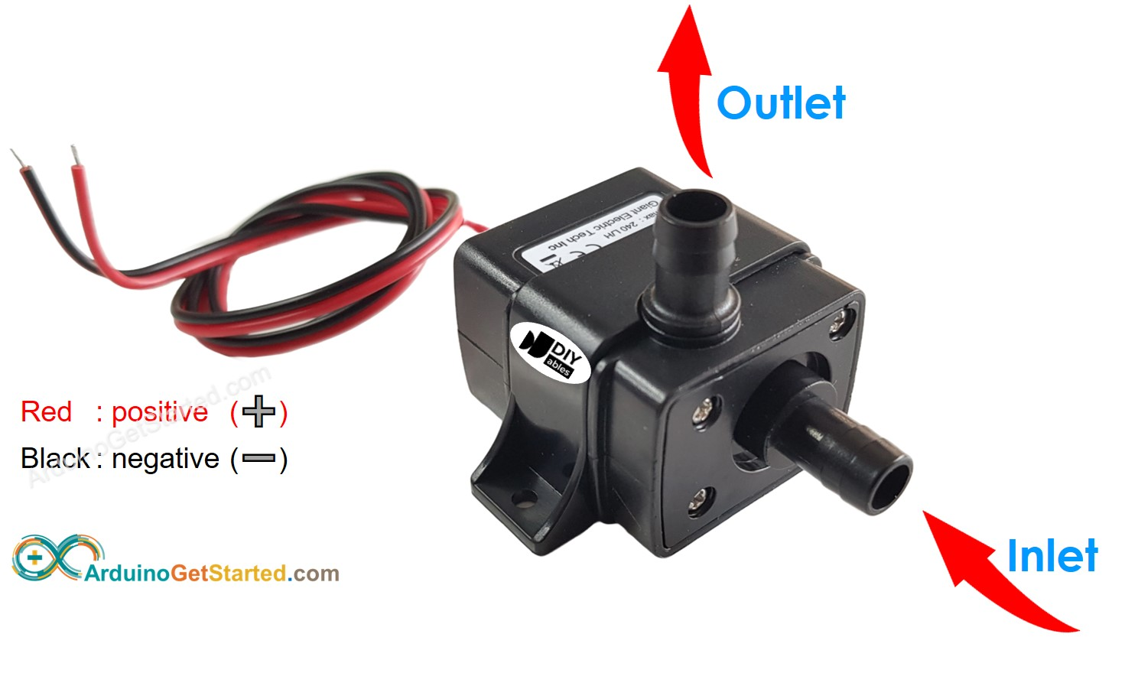

**Price: 630 -1550**

**12V Pump usually has two pins:**

**-Negative (-) pin (black): needs to be connected to GND of DC power supply**

**-Positive (+) pin (red): needs to be connected to 12V of DC power supply**

**-If 12V pump is powered by 12V power supply, it works. To control a pump, we need to use a relay in between Arduino and pump. Arduino can control the pump via the relay**

